Ref. COMM(26)01799 23/07/2026

Press Release
2026 Forecast: Cereal production declines after last year's rebound, while oilseeds and protein crops maintain positive momentum
The experts of the Copa-Cogeca Working Parties on Cereals, Oilseeds and Protein Crops expect a more challenging year for EU cereals in 2026, while oilseeds are forecast to deliver another strong harvest and protein crops are expected to maintain their positive momentum despite lower yields. However, the overall outlook remains highly weather-dependent, and the coming weeks will be crucial in confirming final production, as the recent weather events may have a greater impact than initially expected.
EU-27 cereal production is forecast to reach around 264 million tonnes in 2026, representing a 6.6% decline compared with 2025. Although the cereal area is expected to contract only marginally for most crops, lower yields across much of the EU and a significant reduction in maize area are weighing on production prospects following last year's recovery. This situation is partly linked to the current fertiliser crisis, although its impact on the 2026 harvest is expected to remain limited compared with the much greater effects anticipated for next year.
Total wheat production is forecast to decline by 4.2%, with common wheat down by 4.3% and durum wheat by 2.1%. Barley production is projected to decrease by 3.5%, while maize is expected to record the sharpest decline (-13.9%), mainly due to a 15.2% reduction in sown area despite broadly stable yields, except in France, Hungary and Spain.
Among the other cereals, rye production is forecast to decrease by 4.0%, as improved yields are more than offset by a reduction in planted area. Oat production is expected to decline by 9.3%, while triticale is also projected to record a moderate decrease. Overall, developments remain highly uneven across Member States, with some regions benefiting from favourable growing conditions while others continue to face persistent drought, heat stress and water shortages, reducing yield potential, particularly in Spain and Hungary.
Although the 2026 cereal harvest is expected to remain above the levels recorded during the difficult harvests of recent years, it marks a clear step back from the recovery observed in 2025. This once again highlights the increasing vulnerability of European cereal production to climatic volatility and underlines the importance of maintaining farmers' competitiveness and access to effective production tools.
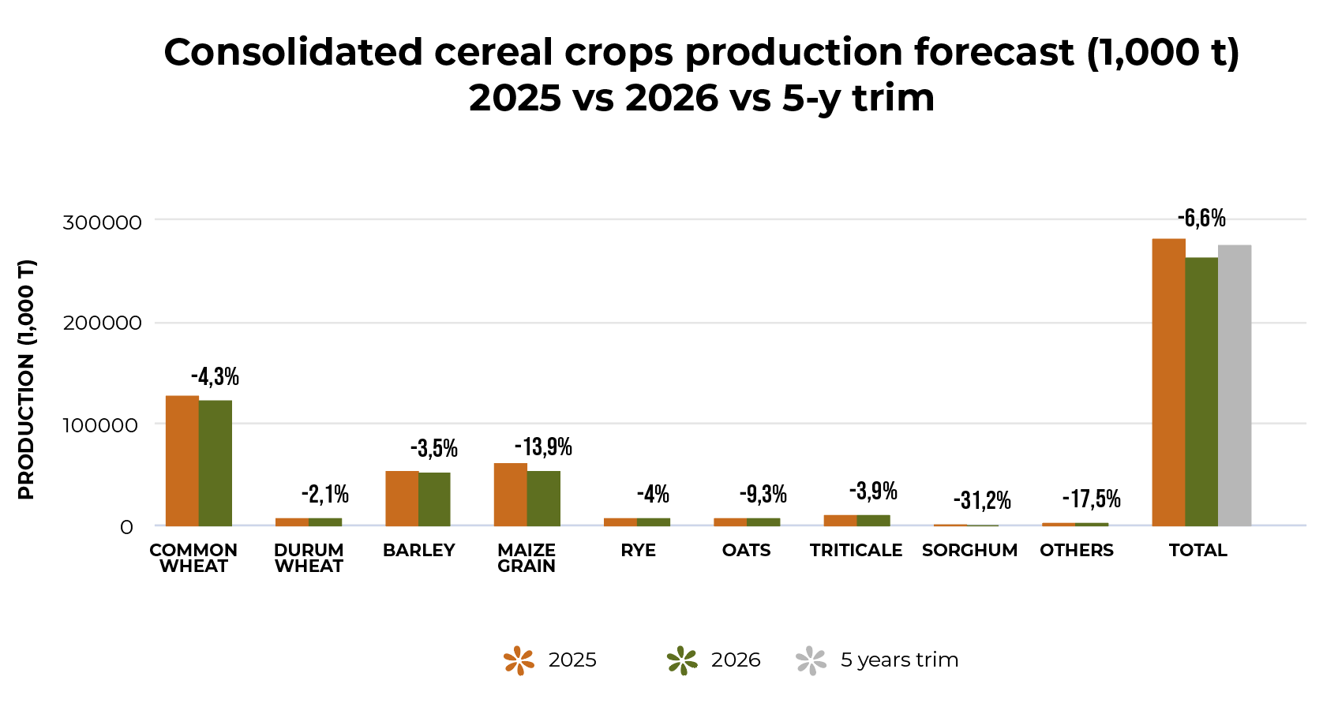
For oilseeds, the 2026 outlook is particularly encouraging, with total EU-27 production forecast to reach 33.3 million tonnes, up 6.8% compared to 2025. The overall oilseed area is expected to expand by 6.6%, while average yields remain broadly stable. However, the severe heatwave at the end of June, followed by the extreme weather events of recent days, particularly heavy rain and hail, may have significantly reduced yields in some countries, notably Germany.
Rapeseed production is projected to increase by 6.4%, supported by a larger planted area, while sunflower production is expected to record the strongest growth (+11.2%), driven by both expanded acreage and improved yields. In contrast, soybean production is forecast to decline by 4.3%, reflecting lower yields despite a slight increase in cultivated area. As with cereals, the outlook varies considerably across Member States, depending on weather conditions and local agronomic circumstances.
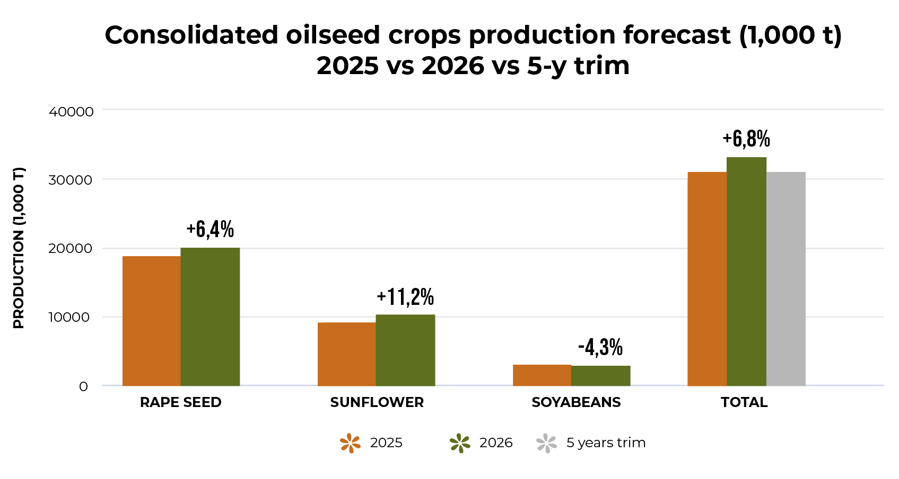
Protein crops continue to show a positive outlook in 2026. EU-27 production is forecast to reach 4.0 million tonnes, an increase of 5.0% compared with 2025. This growth is primarily driven by a significant expansion in cultivated area, more than offsetting lower average yields. Pea production is expected to increase by 4.3%, bean production by 7.2%, while lupin production is projected to decline by 7.0% due to a marked drop in yields despite a larger cultivated area. 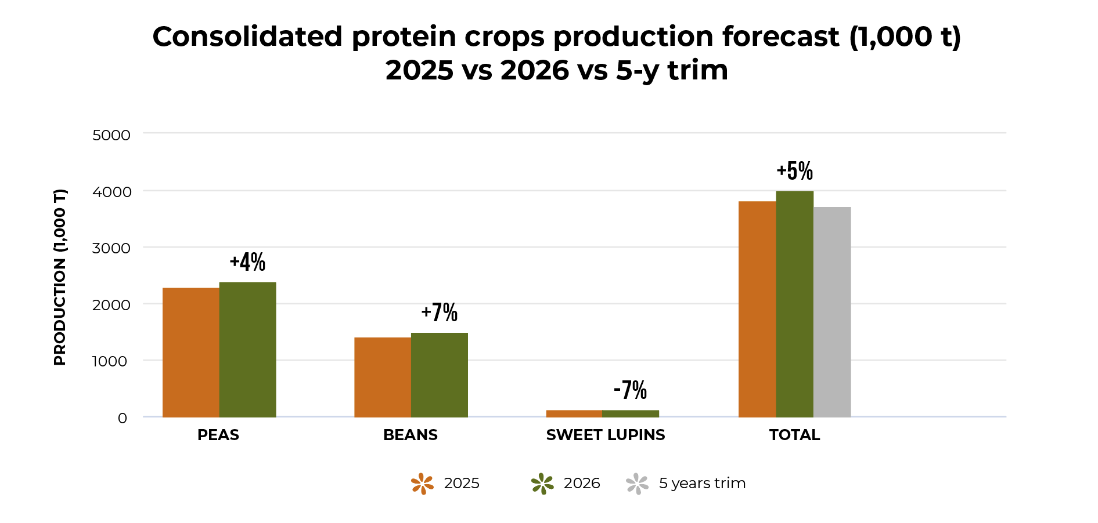
While current forecasts remain broadly positive for oilseeds and protein crops, and cereal production is expected to remain at a satisfactory level despite the decline, the harvest is not yet secured. Continued heatwaves, prolonged drought, or adverse weather during grain filling and harvesting in Member States where harvesting is still underway could still affect final yields. Close monitoring of crop conditions across the EU therefore remains essential, as the coming weeks will be decisive in determining the final outcome of the 2026 harvest.

Read the market report on the harvest forecast for cereals, protein crops and oilseeds in 2026 here: https://copa-cogeca.eu/publications

-END-
Translations will be available in DE, ES, FR, IT, PL and RO on the Copa-Cogeca website soon.
About us - Copa and Cogeca are the united voice of farmers and agri-cooperatives in the EU. Together, we ensure that EU agriculture is sustainable, innovative and competitive, while guaranteeing food security for 500 million people throughout Europe. >>> More information www.copa-cogeca.eu

For further information, please contact
Bruno Menne  Director of Commodities  Bruno.Menne@copa-cogeca.eu | Jean-Baptiste Boucher  Director of Communications  Baptiste.Boucher@copa-cogeca.eu

Press Release Mailing List
Unsubscribe
Subscribe

